Launch an EC2 instance (Linux and Windows) along with a web server. Then, create an EBS volume of 5 GB, attach it to an EC2 machine (Linux and Windows), and take a snapshot. Finally, create an EBS volume using the taken snapshot.
1.EC2 Windows,Linux
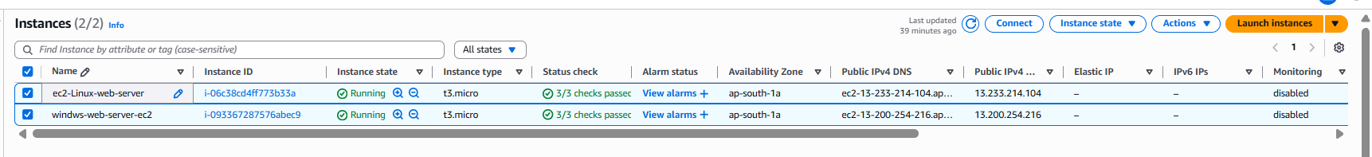
Web Server
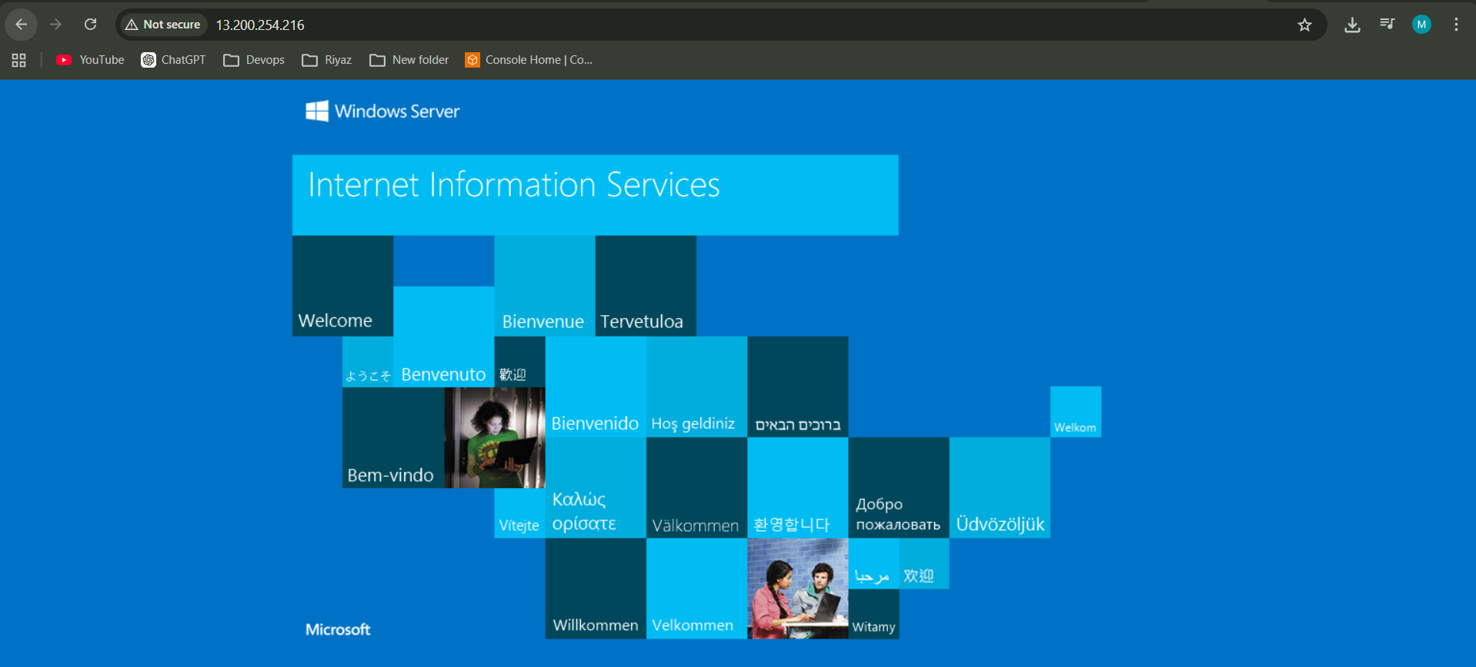
Web server
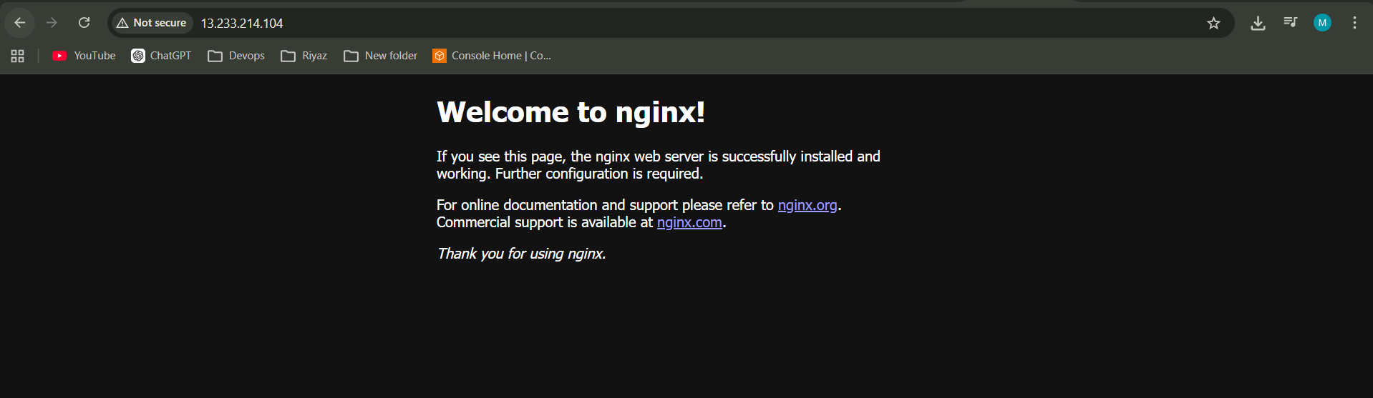
5GB Volume added,
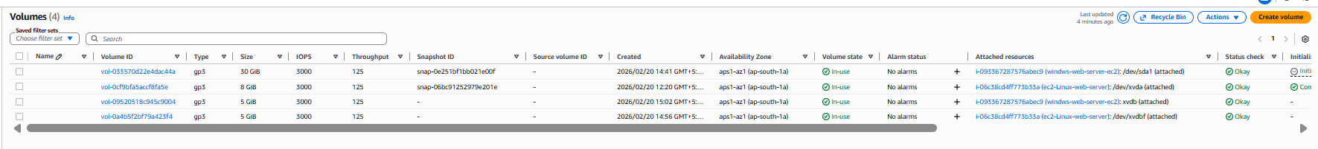

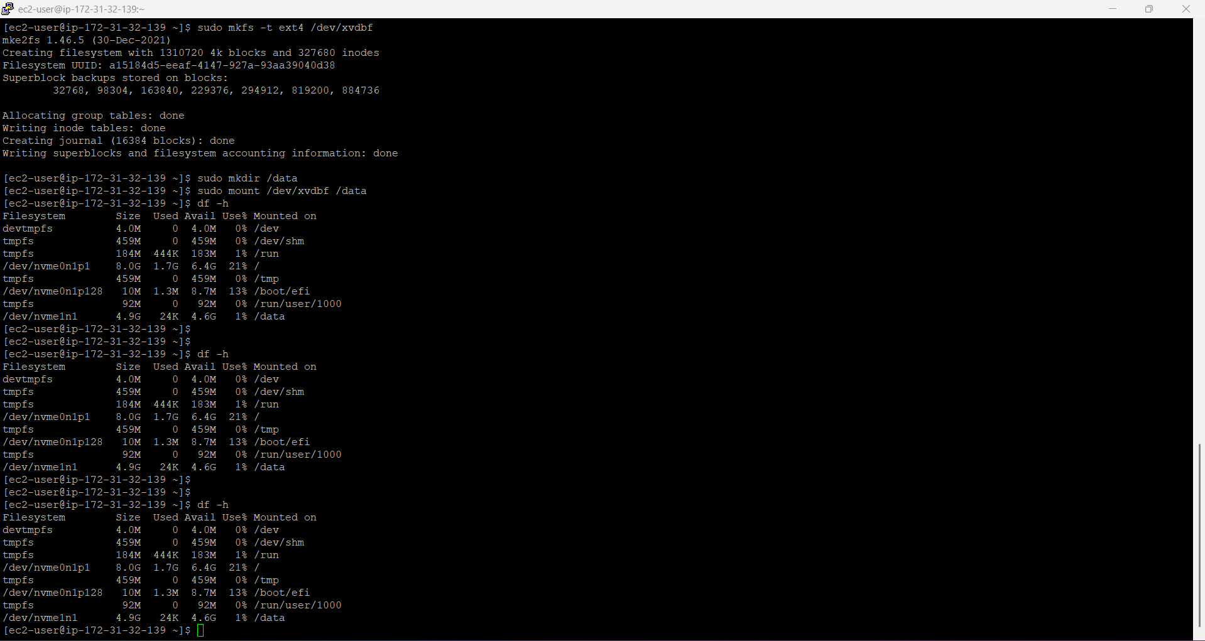
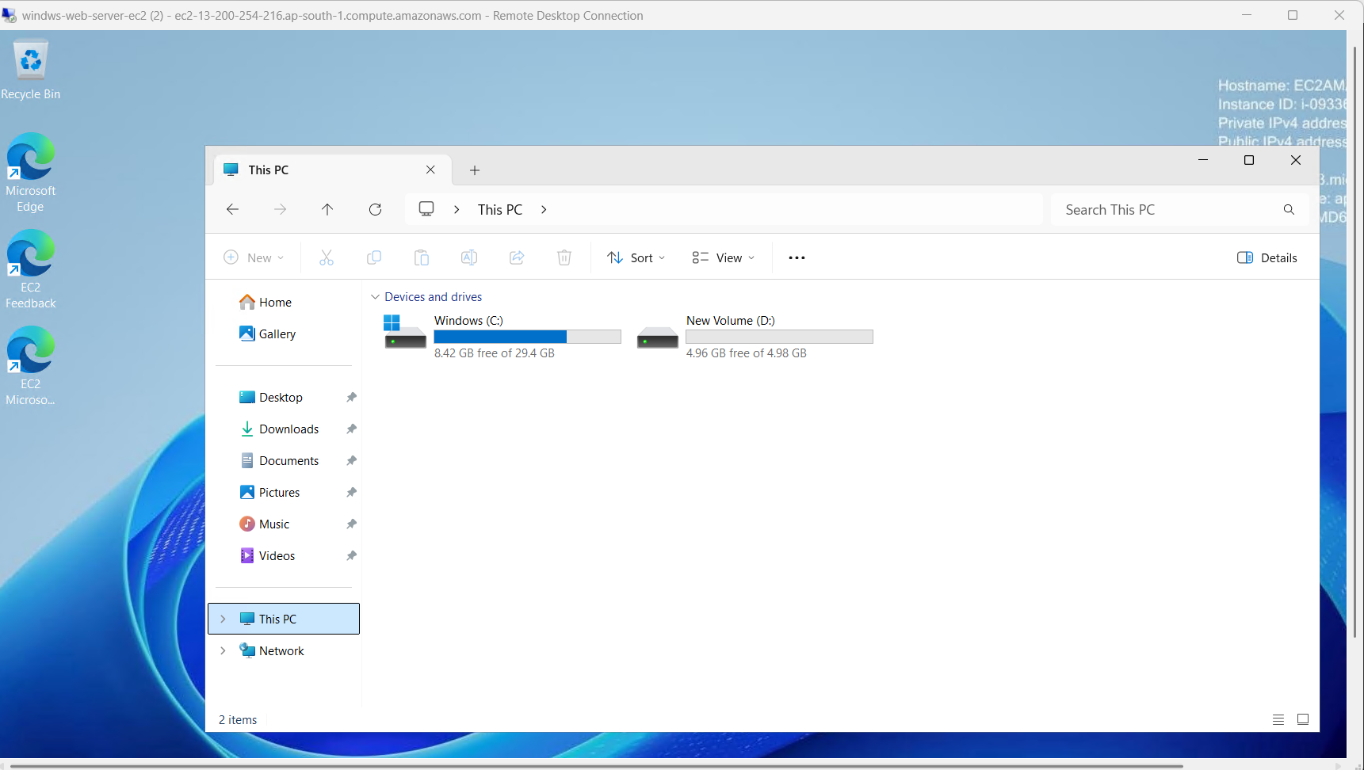
Snapshots
New Volume from Snapshot
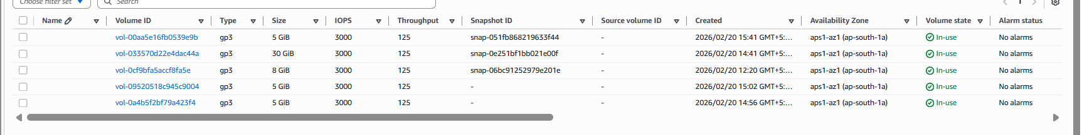
Added:
